Society of Economic Geologists Student Chapter fieldtrip to King Island
Between 13th - 18th April 2021, UTAS Earth Science postgrad students and staff participated in a student-run SEG student chapter fieldtrip to King Island. The aim of this trip was to discover the unique geology of the island, particularly focussing on the Economic geology, a mutual interest amongst all students and staff on the trip. The trip was made possible by Geological Society of Australia sponsorship and fundraising activities by the SEG student chapter. Day 1 involved a trip to King Island Dairy Tasting (to well and truly clog our arteries), followed by introductory geology presentations by Dr. Nicolas Direen (adjunct staff), Prof. David Cooke and Dr. Lejun Zhang (research fellow), including as some lively debates/heated discussions. Day 2 was a trip to Grassy Mine to see the skarn mineralisation and Hornfels of the Grassy Group (including exquisite minerals such as scheelite and garnet). This mine hosts Australia’s largest tungsten deposit, that formed when a large mass of granite intruded into older, calcareous rocks, 351 million years ago (m.y.a.). In the afternoon of day 2 we travelled northeast to Naracoopa, where we saw the equivalent unaltered rocks to those which we saw in the mine. There will be a follow-up visit to the MRT core library to look at drill holes from the Grassy Mine over the coming months. On day 3, we visited Stokes Point, the most southerly point of the island, to see the oldest rocks in the Southeast Australia region: the Mesoproterozoic (1300 m.y.a.) metasediments of the Surprise Bay Formation. Students and staff were thrilled by the stunning metamorphic minerals (garnet and andalusite), the tight folds of the metasediments and the more recently formed ‘calcified forest’. The afternoon involved a transect through the metasediments at Cape Wickham to see the changes in the rocks with increasing proximity to the heat source, a granite intrusion, which caused the contact metamorphism. Day 4’s visit to the City of Melbourne Bay was an exciting change of scene, geologically. Here lies Glacial deposits from Earth’s most severe ice age (‘Snowball Earth’) 636 million years ago and is a globally significant location for paleogeographic reconstructions for the Neoproterozoic glaciation. Some fascinating volcanic rocks can also be found at the City of Melbourne Bay, including some amazing volcanic breccias and pillow lavas, which form when hot magma enters seawater. To conclude our trip on King Island, we held a BBQ celebration at the boathouse and the students ran a self-guided tour of the coast around Currie, where ancient sedimentary rocks of the Surprise Bay Formation can be found, as well as a fault zone and some unusual granitic dykes and sills.
The President of the SEG student Chapter would like to thank the following: the Geological Society of Australia for their sponsorship; Karen Huizing for her assistance in the organisation of the trip; Zeb Zivkovic and Alex Farrar for their research and construction of the itinerary; Nicolas Direen for taking the time to share his knowledge with us; Tim Callaghan for granting us access to the Grassy Mine; David Cooke and Lejun Zhang for their lectures on Skarn mineralisation; and all of the attendees for being so enthusiastic during the fieldtrip.
Keep an eye out for our follow-up report and vlog-style video from the trip!

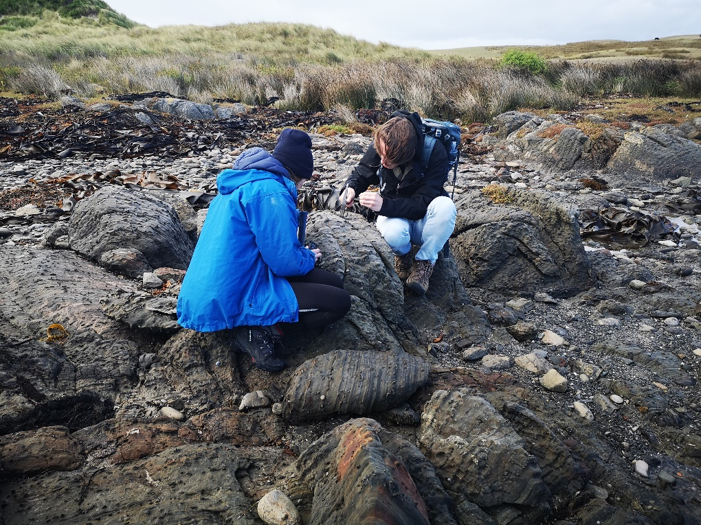
Rhiannon Jones and Thomas Schaap checking out the amazing Amphibole and garnet porphyroblasts (a mineral formed through metamorphism) at Stokes Point

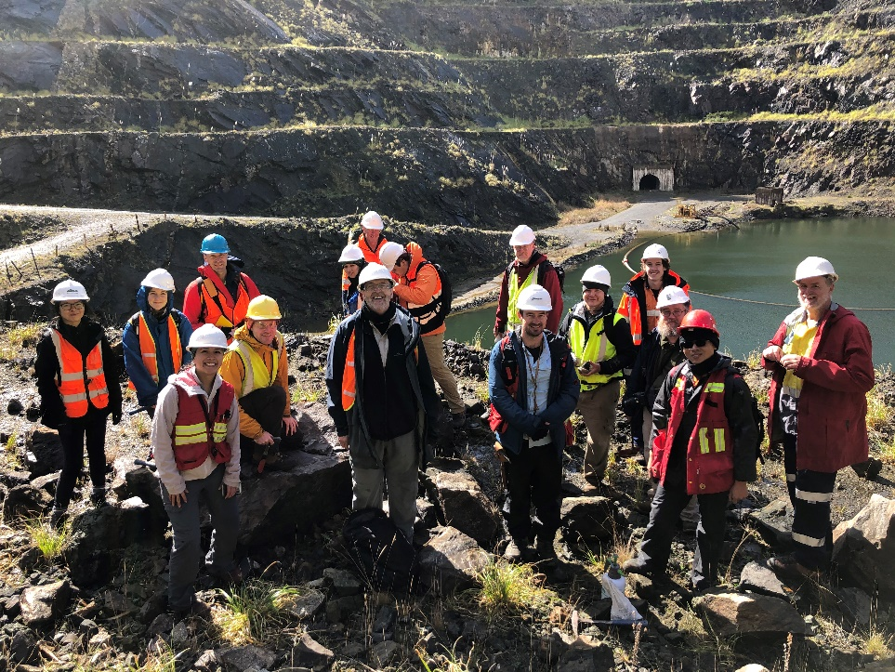
Group photo at Grassy Mine. The mine contains scheelite, an important ore of Tungsten

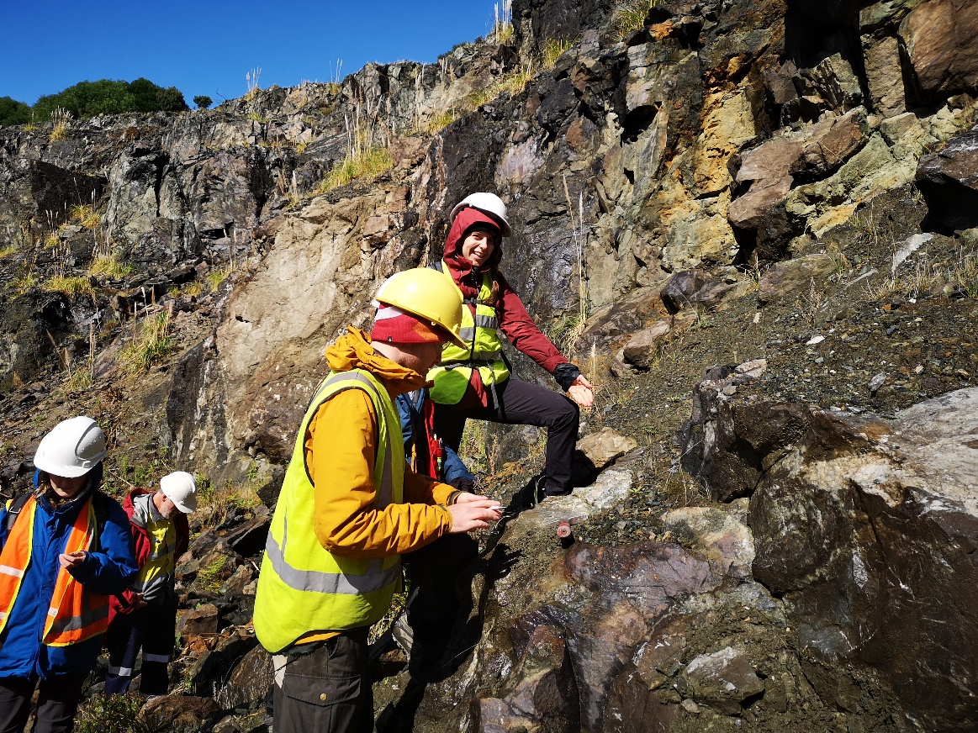
Max Hohl and Hannah Moore checking out the metamorphic rocks in Grassy Mine.

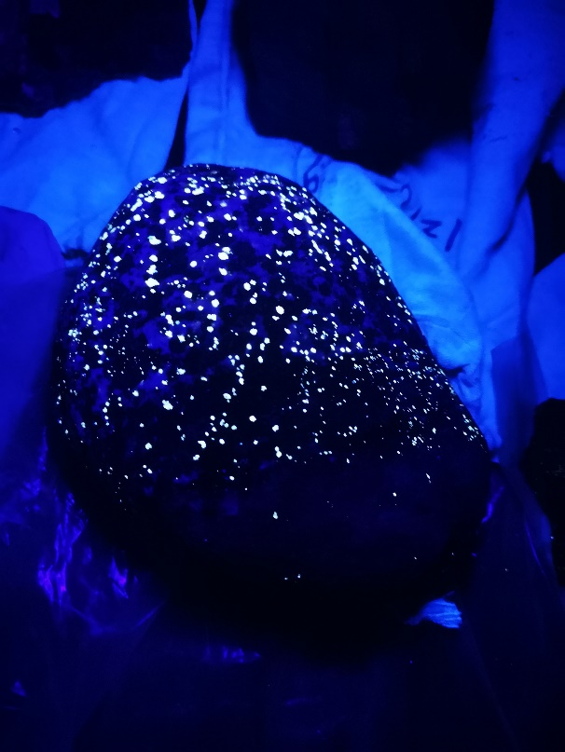
Scheelite (found in Grassy mine) fluoresces under shortwave ultraviolet light. The other, less brightly fluorescing minerals are likely to be calcite.

Nicolas Direen, adjunct staff at CODES and guide for the trip, describing the Cottons Breccia in City of Melbourne Bay, a carbonate-rich breccia and dolostone deposited during ‘Snowball Earth’ and its aftermath

